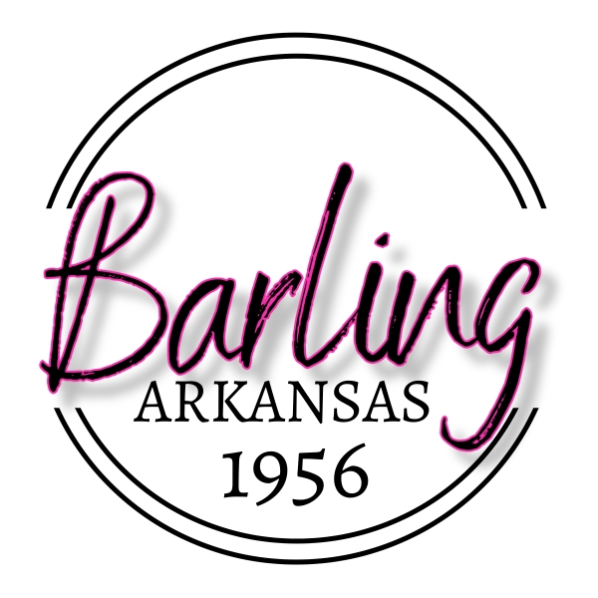
PO Box 23039 Barling, Arkansas 72923-0039
(479) 452-1550

AGENDA
BOARD OF DIRECTORS MEETING
TUESDAY APRIL 22, 2025
5:30 P.M.
CITY HALL

CALL TO ORDER
PLEDGE OF ALLEGIANCE
INVOCATION
ROLL CALL

- APPROVAL OF MINUTES OF APRIL 8, 2025

2. PUBLIC INPUT (LIMIT 2 MINUTES PER PERSON) AGENDA ITEMS ONLY

3. UNFINISHED BUSINESS

- CONSIDERATION AND DISCUSSION OF ORDINANCE 518 GOVERNING THE OWNERSHIP AND CONTROL OF ANIMALS IN THE CITYOF BARLING

4. NEW BUSINESS

- CONSIDERATION OF 2025 FIRST QUARTER BUDGET AND ADJUSTMENTS AND
RESOLUTION 25-04 PROVIDING FOR THE APPROVAL OF THE FIRST QUARTER
BUDGET ADJUSTMENTS

- CONSIDERATION OF RESOLUTION 25-05 REGARDING THE VACANCY AND APPOINTMENT OF THE POSITION OF WARD 4 DIRECTOR

5. DEPARTMENT HEAD REPORTS

6. CITY ADMINISTRATOR REPORT

7. ANNOUNCEMENTS

8. PUBLIC INPUT (LIMIT 2 MINUTES PER PERSON) NON-AGENDA ITEMS

9. ADJOURN

